Simulation results:
Case: 1
Different charging modes (0.52 to 1 solar and wind disconnected case)
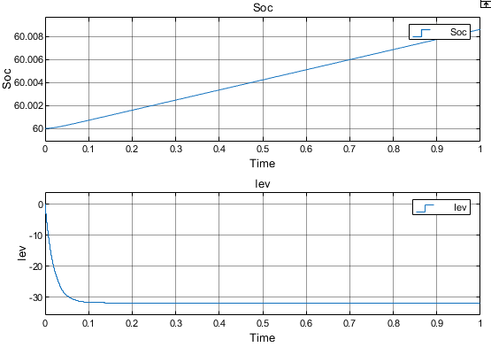
SOC & IEV
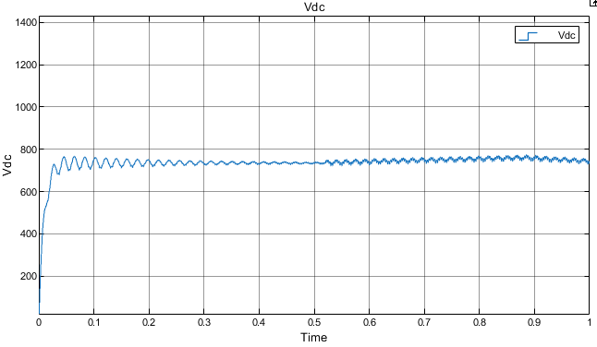
Vdc
Load variation:
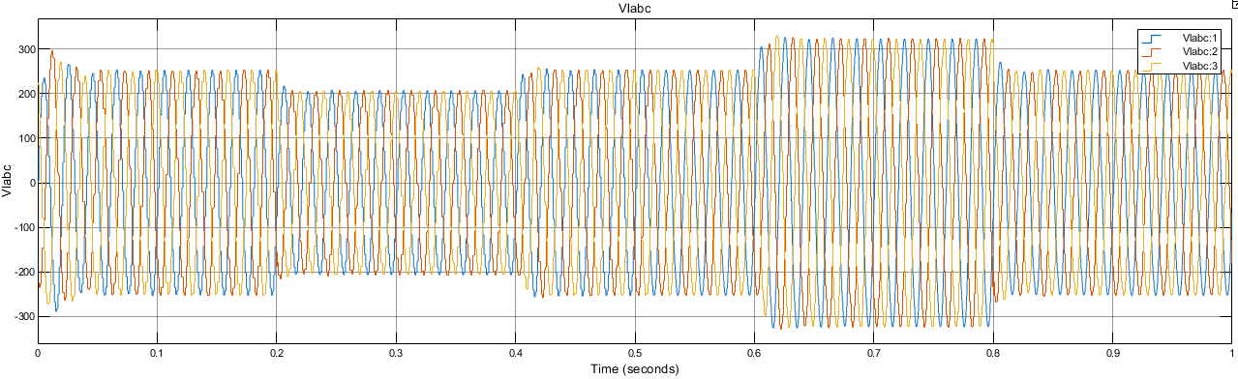
Vlabc
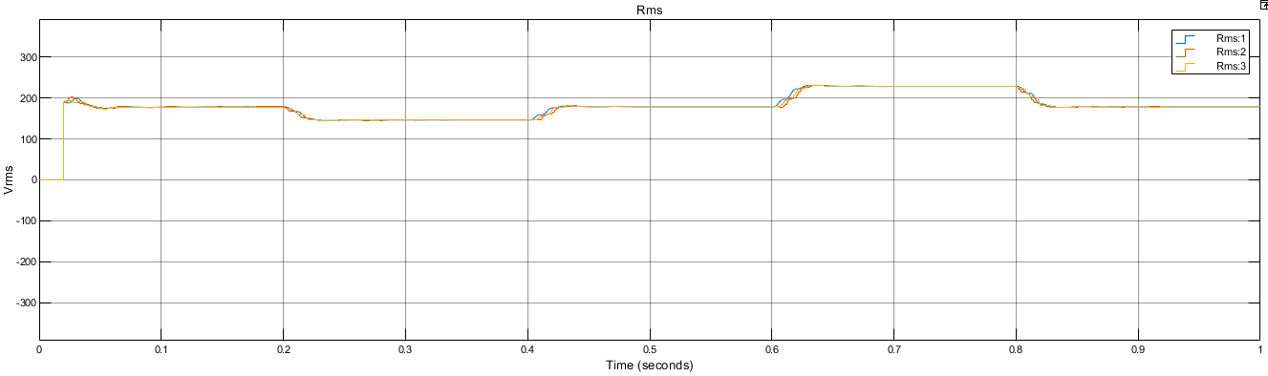
Vlrms
Dstatcom based results:
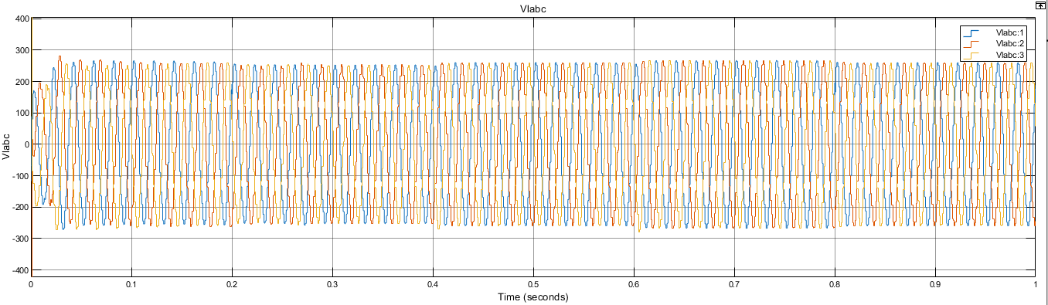
Vlabc
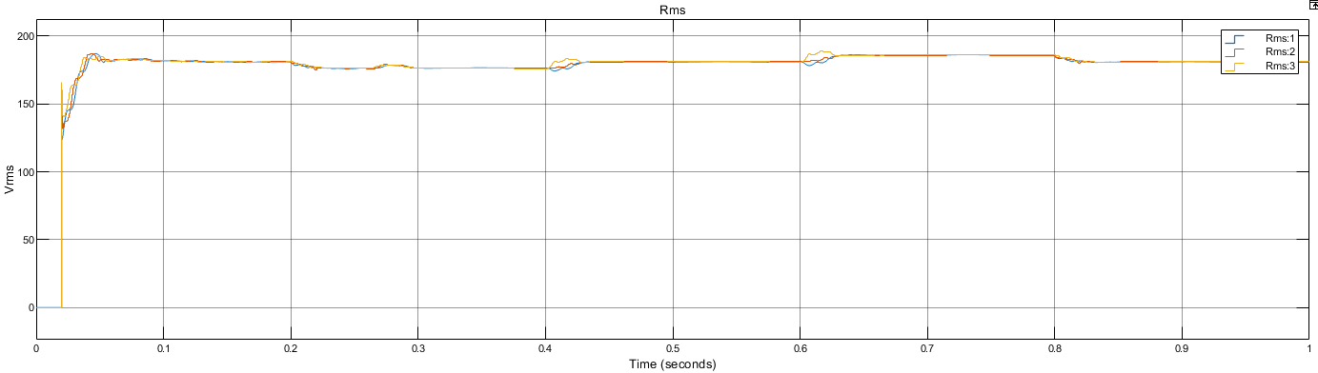
Vlrms
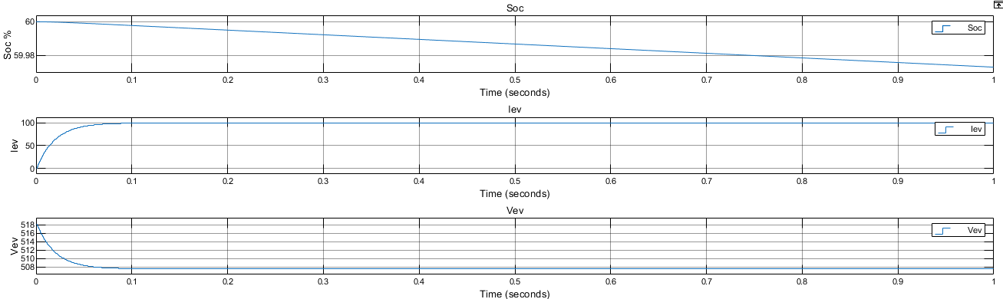
EV side Vev, Iev & SOC

